1. Create a database <yourname>dbms3
Query

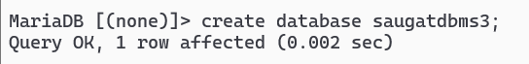
2. Use Current Databse: USE <yourname>dbms3
Query:

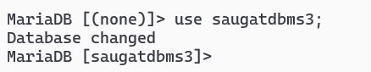
3.Create tables
- student (id, name,gender,program,contact_number,address)
Query:

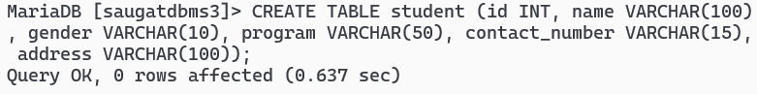
- teacher (id, name, subject, contact_number, address,email)
Query:

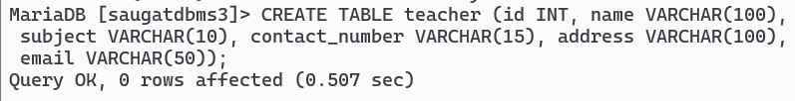
- See detail of Tables
- DESCRIBE student
Query:

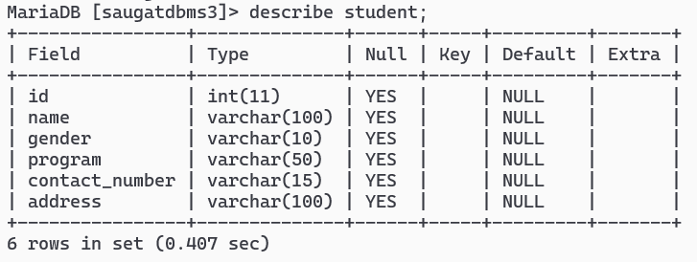
ii. DESCRIBE teacher
Query:

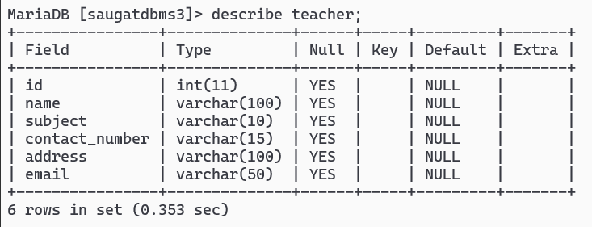

4. Insert Sample Data in tables
- Insert into student:
Query:

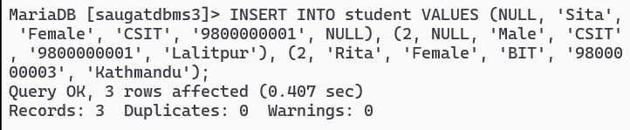

- Insert into teacher:
Query:

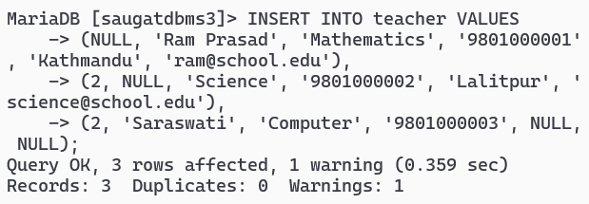

c. Check inserted data in tables
i. Query

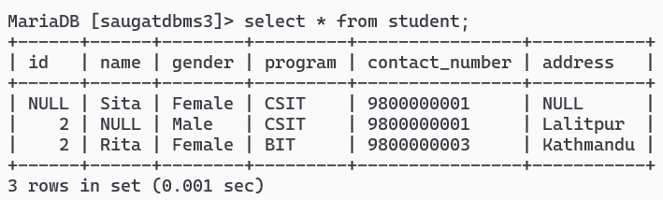
ii.Query:

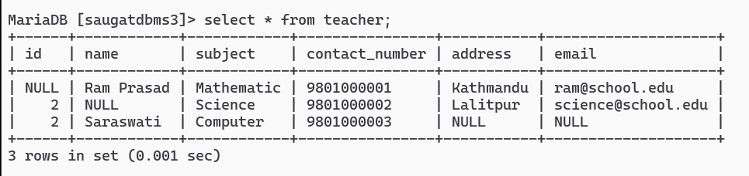
5. Add NOT NULL Constraints
- Add NOT NULL Constraint in student table for necessary attributes
Query:

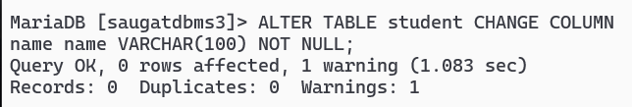

- Add NOT NULL Constraint in teacher table for necessary attributes
Query:

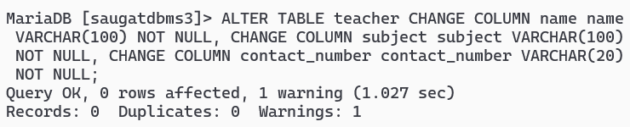
- Test violation of NOT NULL Constraint in tables by INSERTING NULL values
Query:

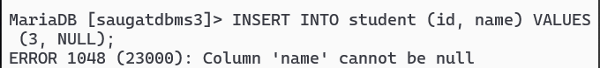

- Add UNIQUE Constraints (Require deletion of previous duplicate data)
a. DELETE FROM <tablename>
Query:

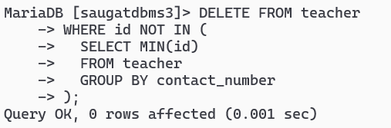
b. Add UNIQUE Constraint in student table for necessary attributes
Query:

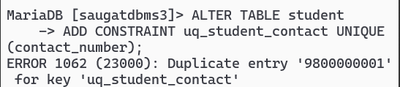
Query:

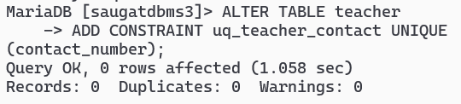
c. Add UNIQUE Constraint in teacher table for necessary attributes
Query:

Query:

- Test violation of UNIQUE Constraint in tables by INSERTING DUPLICATE values
Query:
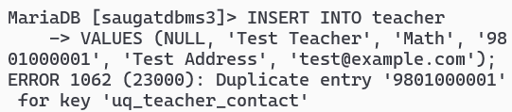
- Set DEFAULT Values
- Add DEFAULT Value in student table for necessary attributes
Query:

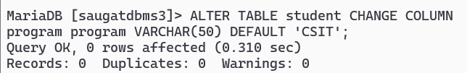
- Add DEFAULT Value in teacher table for necessary attributes
Query:

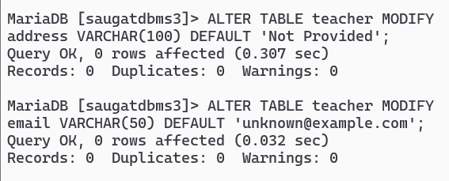
- Test DEFAULT VALUES in rows after INSERTING BLANK values in attributes
Query:

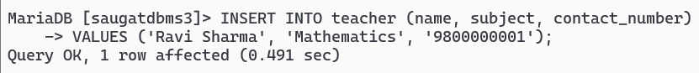
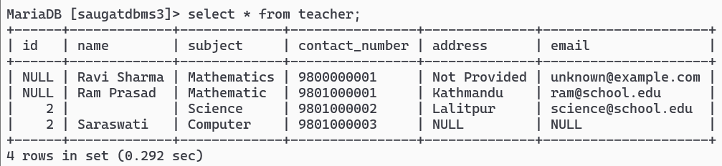

8. Set PRIMARY KEYS
- Add PRIMARY KEY in student table
Query:

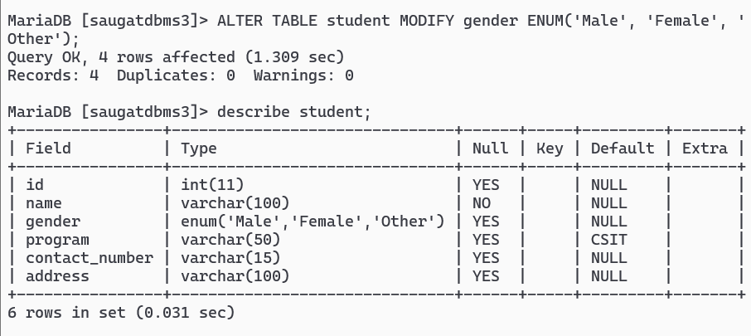
b) Add PRIMARY KEY in teacher table
Query:

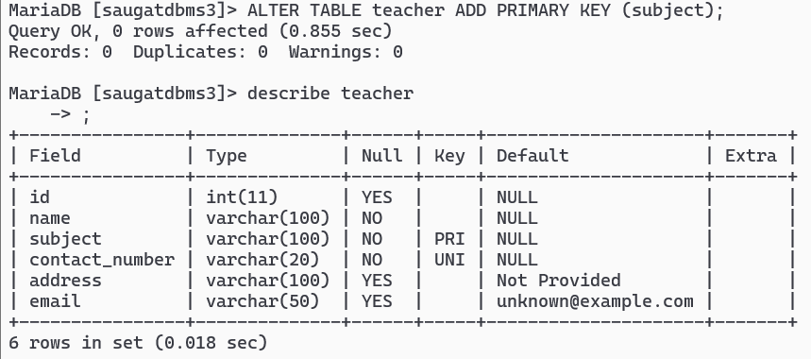

9. Add ENUM and CHECK Constraints
- Add ENUM and CHECK Constraints in student table
i.)Query:

ii.)Query:

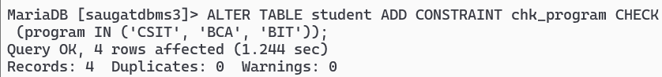

iii.)Query:

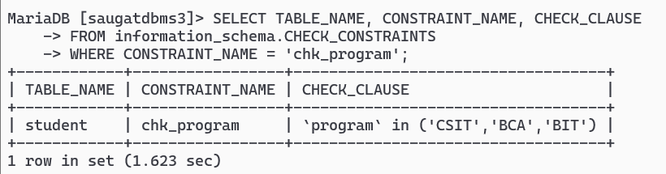

b) Add ENUM and CHECK Constraints in teacher table
i) Query:

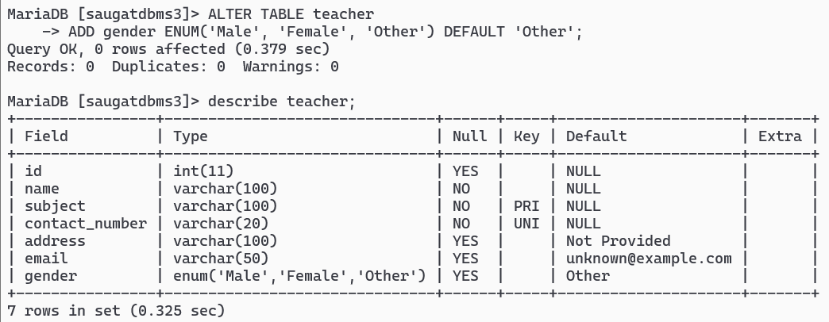

Query:

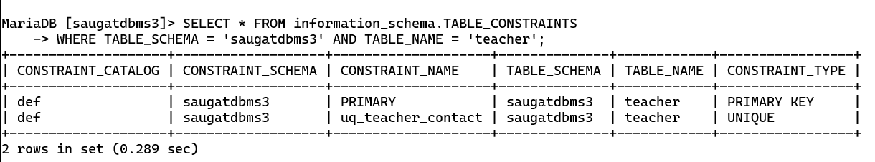
ii) Test ENUM and CHECK Constraints in by INSERTING different values than ENUM and check values in respective attributes.
Query:

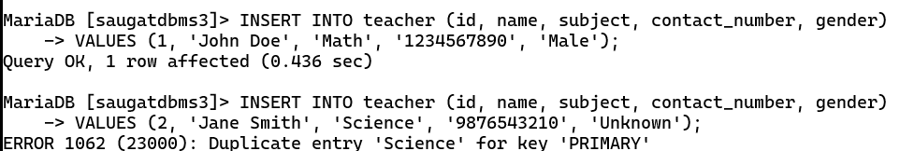

Query:

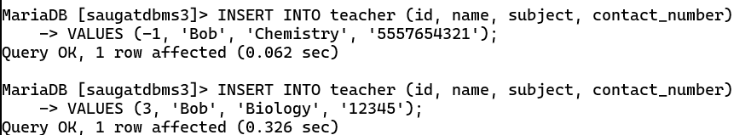

10. List all Constraints
Query:

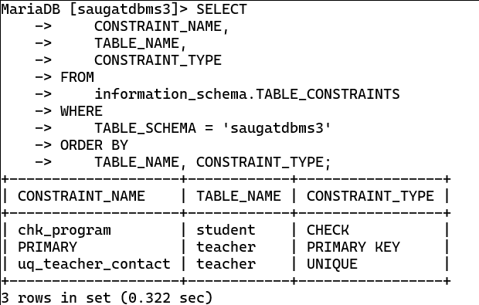

11. Delete All Constraints from tables;
- DROP Constraints from student table
Query:

b) DROP Constraints from teacher table
Query:

c) Test deletion of Constraints in by inserting values having duplicates in respective attributes
Query:

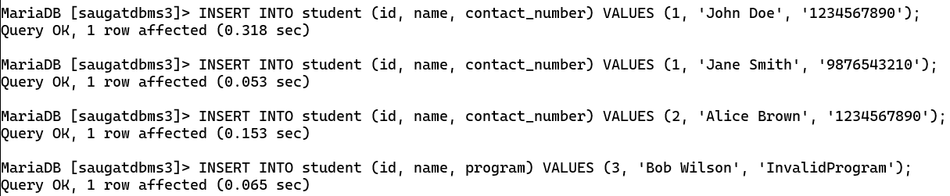

Query:

